Team 9 Test Plan

To: Professor Pisano

From: Team 9

Team: 9

Date: 03/04/2022

Subject: Test Plan

# 1.0 List of Materials

Hardware:

Raspberry Pi 4 B (with 32GB SanDisk SDHC Class 10 card)

Raspberry Pi fans

BerryGPS-IMUv4 (Part number: 8542129523)

Raspberry Pi 4 Camera IR ()

QWIIC Connector and Cable for Raspberry Pi

15W Power Adapter (Pi4)

Mini HDMI to HDMI cable

Active GPS antenna

Software:

C language:

Data collection, from IMU to readable txt file

Python Script:

GPS receiver, from GPS to txt file

Recording video in h.264 format

Image Analysis to capture images of Airspeed dial

XDR File:

The input file to the Xplane simulator.

Google Colab notebook:

Scripts to generate candidate locations of airspeed dial

# 2.0 Equipment Setup

Raspberry Pi4:

1. Enable i2c interface
2. Enable Serial port interface
3. Disabled Serial console
4. Run IMU_interface.c
5. Run GPS.py
6. Run Test.py

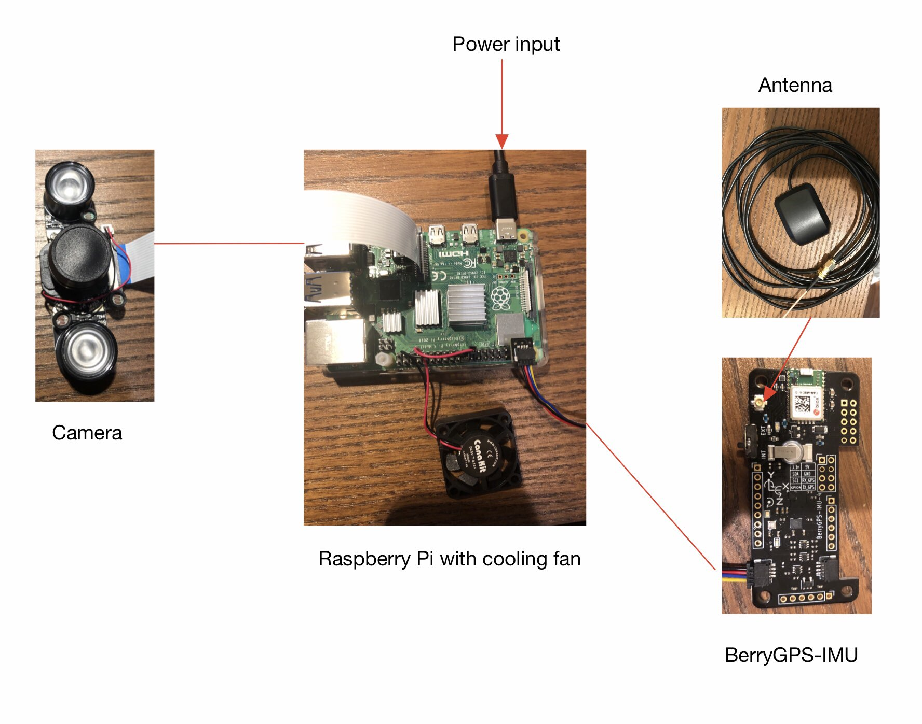

# 3.0 Test Procedure

Test 1: Extract data from sensors

1. Place the BerryGPS-IMU outdoor
2. Get the result data which includes barometer, temperature, altitude, longitude, latitude, pitch, roll, yaw from output data file.
3. Place the BerryGPS-IMU indoor
4. Get the same result data again
5. Compare the result data with the actual data which could be referenced on the Internet and make sure the system is working properly and precisely.

Test 2: Calculate candidate positions of airspeed dial from real world image

1. Load real image of client’s airspeed dial into notebook
2. Run cells in notebook
3. Check if any candidate airspeed dial positions go through the center of the dial

# 4.0 Measurements and Criteria for Success

Test 1: Extract data from sensors

1. Roll, Pitch, and Yaw: The output data of roll, pitch, and yaw match the movement of the BerryGPS-IMU.
2. GPS: The output data of GPS will show it is trying to search the satellite signal.
3. Camera: The camera will record the video under any light circumstance.
4. Output Data: The output data of altitude will match the altitude of Boston.

Test 2: Find the position of the airspeed dial from the image

1. Output image: The output image of the dial should include candidate lines for the position of the airspeed dial, and one of these should go through the center of the dial